Jewish Community Foundation of Greater Mercer

Board of Trustees Meeting

January 29, 2024 at 7:30 PM

**Attendees:** Howard Cohen, Susan Falcon, Michael Feldstein, Harvey Fram, Joyce Kalstein, Stephanie Koren, Miki Krakauer, Chip Loeb, Michael Manning, Jeff Miller, Linda Meisel, Jonathan Nemeth, James Schragger, Jill Schwartz-Chevlin, Joanne Snow, Josh Waldorf, Tiffany Willner, Marc Wisotsky, Walter Yosafat , and Brenda Zlatin

**Absent**: Alex Simanovsky, Scott Schaffer , Oliver Pimley

**Mission statement review by the Board**

The Foundation is organized to promote philanthropy and to further the charitable needs of the Jewish community, other charitable institutions, and community organizations.

**Agenda**

* Call to order
* President’s Report
* Treasurer’s Report
* Executive Director’s Report
* Investment committee report
* Affiliation Committee Report and Recommendation
* Board discussion
* Upcoming Programs and Activities
* Good and Welfare
* Adjournment

Minutes from November 27, 2023 were approved.

Welcome Jonathan Nemeth who is joining us replacing Steve Lieberman due to his new position as the Federation of West Central treasurer.

**Fund Activity and Asset Update - Linda**  
FY24 To Date (July 1, 2023 – January 5, 2024)

* **Number of Funds**

Foundation Funds 5

Custodial Funds 33

Permanently Restricted 22

Temporarily Restricted 11

Donor Advised Funds 82

**Total: 153**

* **Closed Funds 0**
* **Contributions: 85 transactions $2,308,981**
* **Grants: 445 transactions $1,177,045**
* **Assets: 16,652.118 (as of 1.29.24)**

Linda- This is a considerably larger number for contributions. Driving the transactions was the market upswing and increased appreciated stock. People focused on the tax advantage before the end of year.

**The above does not include: - Chip**

* + JCFGM has not received $272,000 from the estate of Rick Glazer z’l
  + Ewing property
  + Interest in a commercial building (inside a DAF)

**Three year overview FY21, FY22, FY 23**

* + 42 Funds were opened
  + **Initial contributions: $3,787,987**

**Treasurer’s report – Joyce**

**There is a positive variance – better than budget. Continuing to wait to hear about the retention ERC application which could be $22,000. There is currently a moratorium**

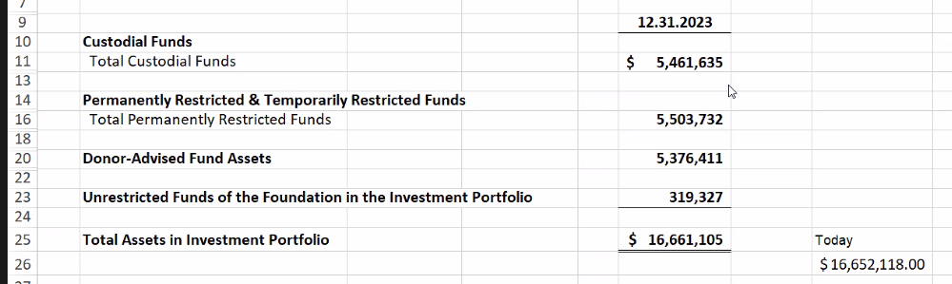

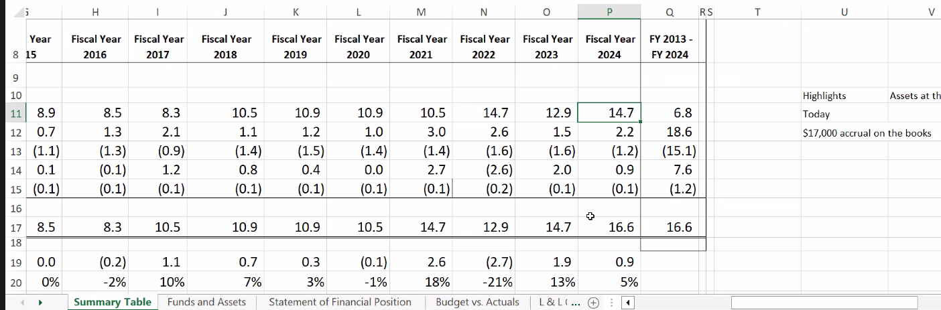

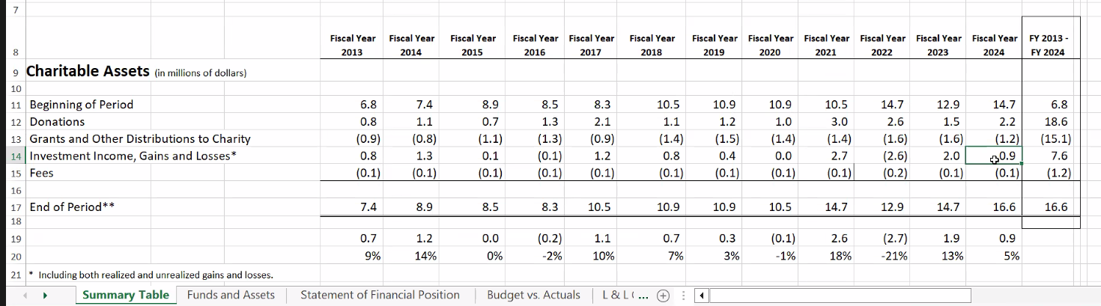

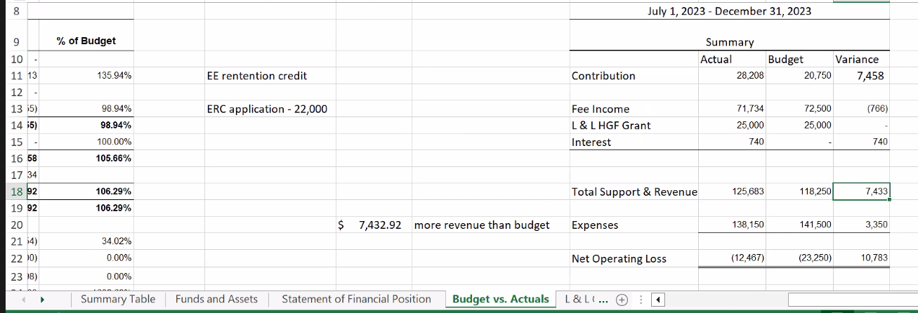

Executive Director’s Report - Linda

**Update on FidTech**

* The JCFGM team has met weekly with the FidTech team since January of last year. Starting now, the teams will be meeting twice a month.
* The FidTech team is responsive to JCFGM staff generated issues
* There is substantial improvement in the accuracy and timeliness of reporting by FidTech than the prior provider
* No more payments to Renaissance

**Update on Social Media engagement – Linda for Wendy**

* JCFGM has been conducting quarterly reviews of social media activity
* There is greater engagement on Facebook than Instagram which speaks to the demographic of our followers
* There is greater engagement when posts include local familiar individuals than text

Investment committee report - Harvey

* For the calendar year (to the end of December) the **portfolio returned 17.07%** compared to 16.83% for the benchmark (as calculated by Vanguard) For the year, both the Equity and Fund Income components of the portfolio were **ahead of their respective benchmarks**.
* For the 3 years and 6 months JCFGM has used Vanguard as the manager, returns of 6.63%net of all Vanguard and mutual fund fees are **ahead of the benchmark**. (6.54% annualized)
* During December, the Investment committee voted to **change the asset allocation from 70/30 to 65/35 after the extremely strong runup in stocks for the year.**
* We are **looking into offering Conservative and Aggressive Portfolio allocation options** in addition to our current Moderate Portfolio allocation option, but that matter remains unresolved.

**Executive Session - NO ADDITIONAL NOTES ADDED**

* Reminder to the board of the confidentiality of the Executive session
* Jewish Community Foundation of Greater Mercer Committee: Chip Loeb, Joyce Kalstein, Susan Falcon, and Jeff Miller

**Upcoming Meetings and Programs**

**February 12, 2024, 7-8pm**

*What should be Top of Mind for the Jewish Community in the 2024 Election Season?*

Featuring Dr. Benjamin Dworkin, Founding Director of the Rowan Institute for Public Policy, and Citizenship (RIPPAC) at Rowan University. Co-sponsored by the Jewish Federations of Princeton Mercer Bucks and West-Central New Jersey. This is a Zoom webinar.

**March 4, 2024, 7-8pm**

*Jewish Life on College Campuses*

Panel featuring student representatives, Rabbi Gil Steinlauf, Center for Jewish Life at Princeton University, and Rabbi Esther Reed, Hillel at Rutgers University. Co-sponsored by the Jewish Federation of Princeton Mercer Bucks. This is a Zoom webinar.

**March 12, 2024, 7-8pm**

*Life & Legacy Workshop: Shining a Spotlight on Life & Legacy Community Leaders*. Featuring Susan Kostin from Stamford, CT, Mindy Holland from Northeast NY, and Linda Moskowitz from Phoenix, AZ. Moderated by Walter Yosafat, JCFGM Trustee. This is a Zoom webinar.

**April 3, 2024, 7-8pm**

*Institutional Roundtable with Linda Meisel and Harvey Fram*

This is a Zoom meeting.

**April 16, 2024, 7-8pm**

*Annual Investment Summit*

This is a Zoom meeting.

**May 23, 2024, 5-7pm**

*Jewish Community Foundation of Greater Mercer 60th Anniversary and Life & Legacy Celebration*

In-Person Cocktail Reception, Location TBA



**Upcoming Meetings**

* Investment committee meeting: March 11, 2024 at 7:30 PM
* Board meeting: March 25, 2024 at 7:30 PM
* Executive Committee: April 15, 2024 at 7:30 PM
* Board Meeting: May 20, 2024 at 7:30 PM
* Annual Meeting: June 10, 2024 at 7:30 PM
* Investment committee meeting: June 17, 2024 at 7:30 PM

**Good and Welfare**

* Scott and Jeri Schaefer are expecting a grandchild in July
* Joanne Snow reported her son has a job with a Hedge fund
* Jill Schwartz Chevlin and Brian Chevlin on the birth of their grandson