**Jewish Community Foundation of Greater Mercer**

**Board of Trustees meeting**

**November 27, 2023**

**Attendees:** Howard Cohen, Susan Falcon, Michael Feldstein, Harvey Fram, Joyce Kalstein, Stephanie Koren, Miki Krakauer, Chip Loeb, Michael Manning, Jeff Miller, Linda Meisel, James Schragger, Jill Schwartz-Chevlin, Joanne Snow, Josh Waldorf, Tiffany Willner, Marc Wisotsky, Brenda Zlatin

**Absent**: Steven Lieberman, Oliver Pimley, Alex Simanovsky, Scott Schaffer and Walter Yosafat

**Mission statement**

The Foundation is organized to promote philanthropy and to further the charitable needs of the Jewish community, other charitable institutions, and community organizations.

**Agenda**

* Call to order
* Minutes of the September 18, 2023 meeting – Approved after 1 correction by acclamation
* President’s Report

Assets and Funds report

Update on Conversations with the Jewish Federation PMB and Jewish Federation West Central

This will include the strategic planning committee report

* Treasurer’s Report
* Executive Director’s Report
* Committee Reports
* Upcoming Foundation programs
* Upcoming Foundation Meetings
* Good and Welfare

**President’s Report - Chip**

* Assets and Funds report
* Update on conversations with Jewish Federation PMB and Jewish Federation West Central.

**Funds and Assets- Chip** **and Linda**  
FYE24 July 1, 2023-November 20, 2023

* **Number of Funds**

Foundation Funds 5

Custodial Funds 33- including new NA’AMAT USA Fund $500K – Great news! A huge accomplishment and congratulations to all who were involved!

Permanently Restricted 22

Temporarily Restricted 11

Donor Advised Funds 82

**Total: 153**

* **Closed Funds 0**
* **Contributions: 45 transactions $1,289.223**
* **Grants: 270 transactions $831,207**
* **Assets: ( as of November 27, 2023) $15,386,299.92**

**Treasurer’s report – Joyce**

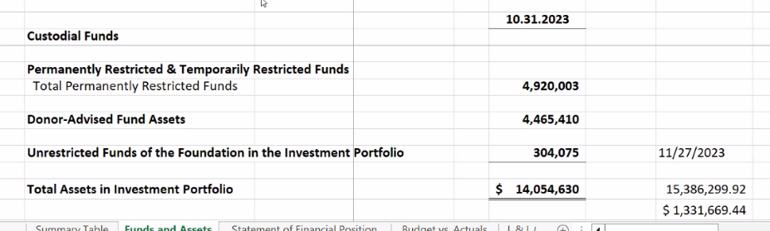

Actual numbers as of October 31st.

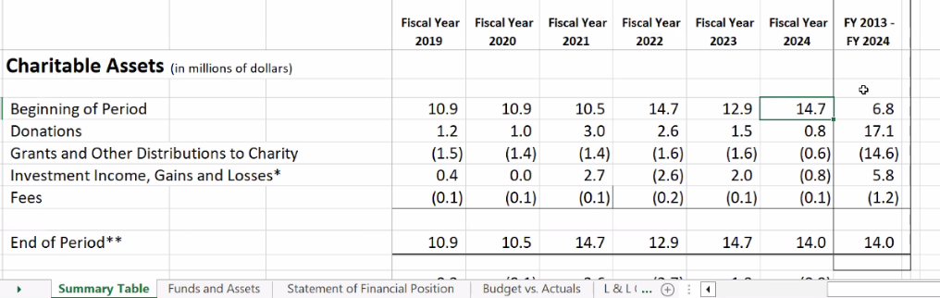

Over budget $7,000. Positive varience which gives us 107,000 instead of 101,000. We are also waiting to hear about a possible $22,000 emplyee retention credit. Paperwork was turned in…

**Executive Director’s report - Linda**

* Congressional Legislation regarding Donor Advised Funds – Proposed legislation will be reviewd by JFNA on the Zoom meeting tomorrow and Linda will share an Executive Summary of the information.

**Social Media** - Please share posts on Instagram, LinkedIn, and Facebook and comment if possible and repost

Update! Recent posts include (see designs on the following slides):

* National Philanthropy Day, honoring Richard Glazer z”l i.e He left legacy to community.
* DAF grants in support of Israel aid -
* Investing in a Jewish Community – It is a great time to use your funds
* Giving through an IRA Required Minimum Distribution (RMD)
* New Institutional Partner: NA’AMAT USA – Welcome!
* New idea for 2024: Board Member Blog – Will pursue it.

Make sure posts are tagged with our partner organizations.

**Life & Legacy**

* Federation PMB Funding $10,000 to fund training and workshops
* Fall Partner Meetings – We are meeting quarterly with each team and collectively with the West Central organizations.
* December 6, 2023 7-8pm

Zoom Workshop featuring **Powerhouse Communities – Best Practices**

* **Legacy Shabbats**

Kehilat Hanahar – Dec 14 (Hanukkah)

Beth El Synagogue – Jan 6

Adath Israel – Feb 2

Beth Chaim – Feb 16

The Jewish Center – Mar 9

**Board members who are members of these organizations are asked to join us at these events.**

* Tu Bishvat – Digital listing of all L&L donors community wide on Jan 24 – all 690 promise makers those who made promises and those who have passed.
  + Suggestion to add Shalom Heritige who are involved
  + Chabad is not involved.

* L&L Celebration will be combined with the 60th Anniversary gathering on May 23 and will feature a digital Book of Life – more details to come!

**Investment committee - Harvey**

* For the calendar year to date (to the end of October) the portfolio has returned 4.18% compared to 3.37% for the benchmark (calculated by Vanguard) September return-2.50%, **ahead of the benchmark thanks to the actively managed international allocation.**
* For the 3 yrs. 4 months JCFGM has used Vanguard as the fund manager, returns of 3.31% net of all Vanguard and mutual fund fees are **ahead of the benchmark** (3.03% annualized)
* During September, the investment committee voted to make a major change to the fixed income portfolio to take advantage of a recent anomaly in bond yields where each of long-term government bonds has a higher yield than the benchmark. As a result, the fixed income portfolio is now made up of the Vanguard Federal Money Market Fund (60%) and the Vanguard Long-term Treasury Index Fund (40%)where that ration has the same duration risk (interest rate sensitivity) as the benchmark
* **We are looking into offering Conservative and Aggressive Portfolio Allocation options, in addition to our current Moderate Portfolio Allocation option.**

**Insurance review report – Jim**

**Annual Insurance review meeting** was on August 17, 2023. Board Trustees Jim Schragger and Marc Wisotsky, represented the board, Linda Miesel was present as staff. CBIZ was represented by Jeff Perlman and Brian Anstock

* Brian presented the current packet of insurance coverage which includes
* Officers and Directors insurance
* General Liability Coverage
* Cyber and Crime Coverage
* Both Jeff and Brian advised that the current coverage is appropriate for an organization the size of the Foundation
* A copy of the insurance packet is available for view by Board members on the Board portal under institutional documents.

Repurchase in August, if you have questions, please ask.

**Committee reports - Howard**

* Ewing Property update: We were scheduled to meet on November 30, 2023 at 12 noon via zoom. Glitch on the Trustee side
* Audit Committee: The audit Field work is scheduled to be completed by **December 31, 2023**. – **Mark W.** In February, we should have a draft if there are no issues.

**Upcoming Foundation programs – Please attend if possible**

**December 3, 2023, 10:30-11:30am**

*Four Mothers*

Featuring Dr. Leonard Rutgers, American trained Dutch archaeologist who will offer new insights into the history and ancestry of Ashkenazi Jews. Co-sponsored by the Jewish Federation of West-Central New Jersey.

**February 12, 2024, 7-8pm**

*What should be Top of Mind for the Jewish Community in the 2024 Election Season?*

Featuring Dr. Benjamin Dworkin, Founding Director of the Rowan Institute for Public Policy, and Citizenship (RIPPAC) at Rowan University. Co-sponsored by the Jewish Federations of Princeton Mercer Bucks and West-Central New Jersey.

**March 4, 2024, 7-8pm**

*Jewish Life on College Campuses*

Panel featuring student representatives, Rabbi Gil Steinlauf, Center for Jewish Life at Princeton University, and Rabbi Esther Reed, Hillel at Rutgers University. Co-sponsored by the Jewish Federation of Princeton Mercer Bucks.

Michael F. – Mentioned AJC – Hindu and Jewish celebration yearly which is a great community event.

**May 23, 2024, 5-7pm – *NEW DATE!***

*Jewish Community Foundation of Greater Mercer 60th Anniversary Celebration*

In-Person Cocktail Reception

Upcoming Foundation meetings

* December 4, 2023 at 7 PM Succession committee
* December 11, 2023 at 7 PM Investment committee
* December Executive committee is in the process of being scheduled
* January 29, 2024 Board of Trustees meeting
* February 26,2024 Executive Committee meeting
* March 25, 2024 Board of Trustees Meeting
* April 15, Executive Committee meeting
* May 20, 2024 Board of Trustees meeting- FYE 2025 Budget Presentation
* June 10, 2024 Annual Meeting

**Good and Welfare**

* Mazel Tov to Jeff and Lois Miller IHO the engagement of their daughter Haley to Martin

Happy Hanukkah