**Jewish Community Foundation of Greater Mercer**

**Board of Trustees Meeting**

**5.22.23**

**Attendees:** Ronald Berg, Howard Cohen, Susan Falcon, Harvey Fram, Joyce Kalstein, Stephanie Koren, Chip Loeb, Michael Manning, Jeff Miller, Linda Meisel, Scott Schaffer, Jill Schwartz-Chevlin, Alexander Simanovsky, Joanne Snow, Tiffany Willner, Josh Waldorf, Marc Wisotsky, Walter Yosafat ,and Brenda Zlatin

**Absent**: Michael Feldstein, Rick Glazer, Miki Krakauer, Steven Lieberman, Oliver Jensen Pimley, and James Schragger

**Mission statement**

* The Foundation is organized to promote philanthropy and to further the charitable needs of the Jewish community, other charitable institutions, and community organizations.

**Agenda**

* Call to order
* Mission Statement
* Approval of March Minutes
  + **Minutes** from March 27, 2023 were approved
* President’s Report
* Assets and Fund Activity
* Discussions with Jewish Federation PMB
* JCYF Fund
* Treasurer’s Report
* FYE 2023 Financials
* FYE 2024 Proposed Budget
* Executive Director’s Report
* Committee reports
* Programs/Events/Meetings
* Good and Welfare

**Funds and Assets**   
(FY23 through May 15, 2023)

**Number of Funds**

Permanently Restricted 22

Temporarily Restricted 11

Custodial Funds 32

Donor Advised Funds 81 *(including 2 mitzvah funds)*

Foundation Funds 5

**Total 151**

**New Funds**  10; 2 custodial, 2 mitzvah, 6 DAFs

**Closed Funds** 4; 2 DAFs, 2 restricted

**Closed Funds: Soviet Resettlement Fund, JCC Cohen Fund, 2 person DAF’s that were combined to a new fund.**

**Contributions** $1,468,444

**Grants**  $1,302,174

**Assets: $14,327,769 (May 22, 2023)**

The new system with Fidtech will be able to have fund holders add money into funds by credit card.

**President’s Report -Chip**

Discussions with the Jewish Federation of Princeton Mercer Bucks

**Talks with Federation**- Dan H. is not going to serve a third term as President of the Federation. The Federation nominating committee is working on candidates. Chip is looking to schedule a meeting to get back on track and see if there is a strategic opportunity. The timeline has now changed. It has been extended.

**Jewish Community Youth Foundation Fund and Hebrew Free Loan**

* The Hebrew Free Loan committee of JFCS has been eliminated.
* The JFCS board has voted to move the JFCS Hebrew Free Loan funds to a Custodial Fund at JCFGM. The fund is currently at $49,442
* JCFGM has a permanently restricted Hebrew Free Loan fund that has assets of $14,670
* The Executive Committee discussed and recommends that since there is no longer a HFL committee operating in this community, the funds in the Restricted HFL Fund be set aside for scholarships for student participation in JCYF – this would continue it’s use for individuals in need and support students having the experience who might not otherwise be able to participate. JCYF would receive a 4% annual grant for those scholarships.
  + Preliminary restricted… It was asked why it is not a custodial fund?
  + Joanne had a several questions related to the fund who it would be used for and the guidelines. As HFL funds these funds have had no activity in years.

The general recommendation is the fund will be renamed and set up to have a 4% annual distribution

Joanne suggested that there is a need to make sure that the language is clear and establish where the funds go if the program should the JCYF program end

**Treasurer’s Report – Joyce**

**Numbers as April 30. 2023**

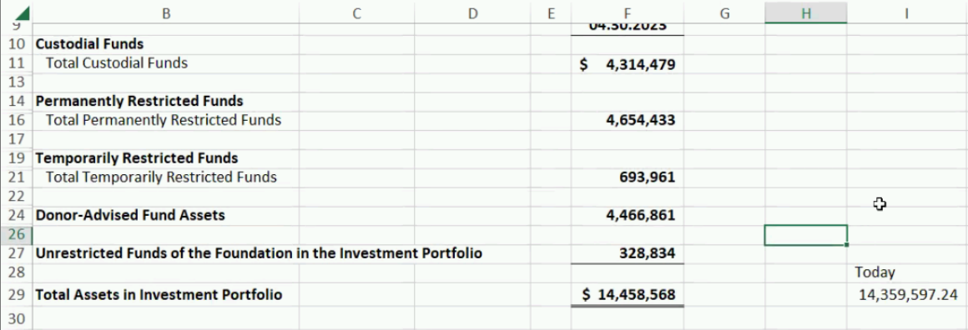

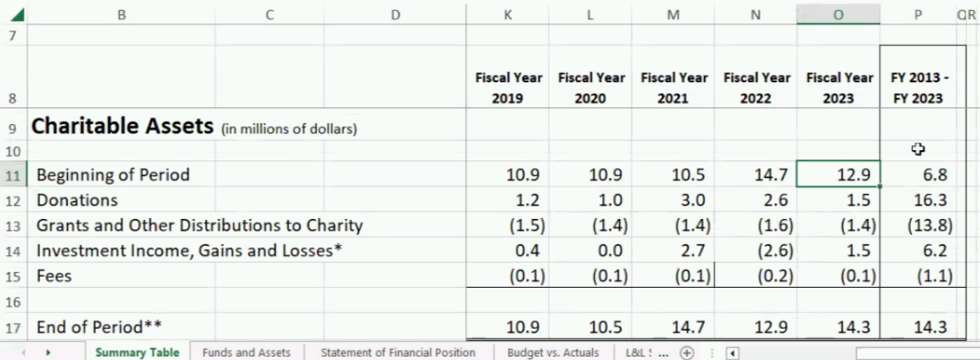

Charitable Assets 12.9 -> 14.3 increase

Reminder: fees are approximately 1% of funds and portfolio is lower than expected.

To sustain the JCF, new sources of revenue are needed, and the stock market needs to recover. All figures are current with today’s numbers including Life and Legacy that will receive the $40,000 at the end of June. That number is already in the figures.

**Once charts were reviewed:** There was discussion about the proposed budget and it the Board was reminded that the Executive Board already approved the Proposed budget for next year. The budget reports are posted on the Board Portal on the website.

Discussion of the expense of the auditor and accountant – following the guidelines and the charity paperwork without conflict of interest for a non-for-profit, it is a necessity to outsource those two tasks.

Chip thanked the team for working on the budget.

Howard- committee’s job = a leap of faith… recommendation that budget be evaluated quarterly.  
Howard – vote

Stephanie- 2nd

Chip counted- 16 for, 0 against, and 1 abstained (Ron)

**Executive Director’s report - Linda**

* **Technology**: There continue to be weekly meetings with the FidTech team. At this point, Ren has provided all the data needed and FidTech is has **completed the working sandbox**. The target for Go Live is June 1. All Fund holders have received a letter reporting on the change in Back office provider and will be instructed not to enter grants individually from **May 30 through June 18**. During that time only JCFGM staff will enter grant information to minimize user error in grant entry.
* **Voices of Princeton**: The Jewish Community Foundation in collaboration with both the Princeton Public Library and Historical Society of Princeton is working on a Jewish Legacy project of oral Jewish histories. A reception was held on May 10, 2023 to launch the Voices project. There were about 50 people who attended the program.The Historical Society will maintain the oral histories on their website in perpetuity. This is an ongoing initiative. **There is also a walking tour.**
* **Life & Legacy Plus**: Year 1 concludes on May 31 and the L&L partners are working hard to meet their goals and achieve the incentive grant of $1,800. To date, 33 Promises have been secured this year among Greater Mercer partners. A spring celebration event is planned for May 23, 5-7pm at Beth Chaim with over 90 people registered. Light dinner and musical entertainment are planned. Currently, the following seven partners have achieved an incentive grant: Adath Israel Congregation, Beth El Synagogue, Congregation Beth Chaim, Congregation Brothers of Israel, Kehilat Hanahar, The Jewish Center of Princeton, and the Jewish Community Foundation.
* We are also working with the L&L teams in Somerset, Hunterdon & Warren – encouraging them to set Life & Legacy goals for this coming year. They are on a calendar year, so the time frame is different than JCFGM and Mercer.
* **Programs and events:**
* *Streets of Gold* program with Leah Boustan-80 attendees
* Voices of Princeton at the Princeton Public Library – May 10, 2023 50 attendees
* Grinspoon Legacy Gathering: May 7-9 attended by Amy, Linda, Don Leibowitz and Karen Brodsky, and JCC Bridgewater ED Laura Friedman

**Grinspoon Life & Legacy**   
Gathering Report

* Key workshop information
* The importance of Legacy conversations including asking donors who left them a legacy?
* **Adaptive Leadership**: How to create change and include stakeholders so that the outcome is one of moving forward together. Change creates loss which complicates how groups adjust to change.
* The Challenge of ensuring that all Legacy promises that are realized are deposited in legacy funds and not used for budget shortfall
* Chartered Philanthropy Advisor (CAP) certification
* The Collaboration of Board, Staff and Volunteers to work to ensure the team has the mindset, will and skill to **sustain the Life & Legacy Program**. The Grinspoon Foundation will be offering workshops for board members starting in Fall 2023.

**Committee Reports**

**Investment Committee - Harvey**

* For the year to date (to the end of April) the portfolio has returned 7.18 % compared to 6.87 % for the benchmark (as calculated by Vanguard)
* For the 2 years and 10 months that JCFGM has used Vanguard as the manager, returns of 4.94% are very slightly ahead of the benchmark(4.80% annualized)
* During the last quarter, the committee voted to replace the Actively managed international funds with the Vanguard International Core Stock Fund (VZICK). The actively managed category represents 14% of the portfolio
* The fixed income portfolio has a shorter duration than the benchmark, and once again that helped the relative performance. Shorter term yields are significantly higher than those of long term bonds.
* **We continue to slowly move out of the Inflated Protected Bond position into the Short Term Treasury fund**

**Committee Reports**

* **Strategic Plan**- Committee will be meeting on May 31 to review task force reports and organize them for a presentation at the June 19 Board meeting – each committee: look and list next steps.
* **Book Awards**: Book Award application has been distributed to high schools and Jewish organizations in Princeton Mercer Bucks, JFEDSHAW – Committee meeting Aug. 7th to review and make recommendations.
* **Personnel Committee**: Staff evaluations reviewed with Linda. Chip and Josh will meet with Linda to review her evaluation. Staff increases are reflected in FY 2024 budget
* **Ewing Property update**
* The property had some offers but very low
* The bank trustee believes the environmental issues are keeping offers from coming close to appraisal amounts. Wells Fargo making it difficult – assets are in a trust that they will lose if property is sold.
* JCFGM team believes **environmental issues** are not as problematic as the bank trustee
* The current broker no longer wants to represent the property, and JCFGM has recommended a more local broker

**Committee reports**

* Nominating committee: The Nominating committee met several times to discuss current board members whose terms were expired in 2023 and the Executive committee positions
* The committee decided that given all the strategic conversations happening at this time, it would be best not to add any new Trustees to the board.
* The nominating committee has completed a slate which will per the bylaws be sent to the Executive committee this week and then 10 days prior to the board meeting sent to all Trustees.

Scott- we are cultivating future leaders.

**JCFGM Programs/Events**

* May 23 – LIFE & LEGACY Spring Celebration
* Congregation Beth Chaim, 5-7pm
* To register: <https://bit.ly/LifeandLegacyCelebration>
* as of today 94 people registered
* June 13 – Annual Investment Summit – *Zoom meeting*
* Featuring Dan Voss, Vanguard

**JCFGM Meetings**

* JCFGM Board meeting: May 22, 2023
* JCFGM Investment Committee meeting: June 12, 2023
* JCFGM Annual Meeting: Monday, June 19, 2023

**Good and Welfare**

* Mazel Tov to Josh Waldorf and Anne Berman Waldorf on the upcoming marriage of their son Sam to Stephanie on May 28, 2023
* Mazel Tov to Eran and Amy Zacks on the upcoming Bar Mitzvah of their son Jacob on June 3, 2023
* Mazel Tov to Mark and Wendy Merkovitz, Mark is the ED of the Jewish Federation PMB on becoming grandparents of Mason Sara Merkovitz

Respectfully submitted,

Tiffany Willner, Secretary