Jewish Community Foundation of Greater Mercer
Executive Committee Meeting
December 19, 2022

Attendees: Michael Feldstein, Joyce Kalstein, Chip Loeb, Linda Meisel, and Tiffany Willner
Not a quorum.

Mission statement
- The Foundation is organized to promote philanthropy and to further the charitable needs of the Jewish community, other charitable institutions, and community organizations.
Agenda
- Call to Order
- President’s Report
  - Assets and Activity
  - FidTech
  - Federation
- Treasurer’s Report
- Investment committee report
- Executive Director’s Report
- Grants to partners via DAFs at year end
- Strategic Planning update
- Communications Consultant
- JCFGM Programs
- Board Talking Points

Funds and Assets
Number of Funds as of 12.12.22
Permanently Restricted 24
Temporarily Restricted 11
Custodial Funds 31
Donor Advised Funds 82 (including one pending DAF)
Foundation Funds 5
Total 153

New Funds in FY23:
Custodial Funds 1 and 1 pending
Donor Advised Funds 7 *
Total 8
* One new DAF is our inaugural Mitzvah Fund, co-sponsored by Jewish Federation PMB and in partnership with JFCS and JCYF.
Contributions as of 12.12.22 $470,230
Grants as of 12.12.22 $766,680
Assets: $13,349,665.01 (12.19.22)

FidTech Status
- Contract with FidTech has been signed
- Renaissance has been notified and a Termination date of 7/31/23 agreed upon – there has been no word about monies previously owed.
- The JCFGM team met with the FidTech team for an initial meeting
- A workplan with calendar and benchmark dates is being developed

Treasurer’s Report

Skipped to discussion around Federation-
- 1.5 years ago Federation was supposed to start a Life and Legacy Program - $2.500 award x2 to start (incentive) = Did not start due to time, resourced, and bandwidth within Federation
- Keep in confidence- Dan from Federation approached the Foundation to explore a more solidified relationship with Foundation.
  - Possible merger, strategic alternative, share more or reunite in some capacity
  - “premature baby” possibly a great opportunity
Chip wants to pursue it.
Michael- Happy with Chips thoughts- concern with staffing (Mark) one or ones to get
Moving forward- synergy with JFC, other Federations, Agencies – exploring options
Federation is impressed with how JFC handles money
- Foundation: Money, Programing
- Could benefit both
Linda- Jewish Columbus, Shalom Austin, and Phoenix, AZ – could use as models, did a similar merge in the past 3-5 years
Chip – legal separation, details, operational combination. Goal: to make both organizations stronger
Michael- who is in the room is important to its success.
Joyce- Pulling strengths = positive. We do need to keep in mind why we split.
Chip – Timing of splits = long gap between them.
Linda – good time while we are exploring strategic plans
Tiffany – It sound promising. Our programming is strong and can be stronger together. Timing is optimal with what the Foundations goals are right now.
Joyce- continue the conversation, would we share staffing, space, databases?

Timing- Dan is eager, it would be ambitious to merge by the end of the fiscal year.

Michael – end of the year vs. fiscal year to work a campaign

Lists: Make lists of what both organizations do and what overlaps.

Joyce- administration leadership
Michael- committees, legacy gifts, Federation’s “ Women’s Campaign”

Rich Caster, CEO in Phoenix – 2 boards + joined board to protect entities and assets, judiciary work chart – “ask”
Chip- always a concern – not to underestimate the administrative duties of the Foundation
Michael – Dan – best to expect responsibilities are paramount – “sustainability is key”
Dan realizes the Federation in going to be there at the level he leads – strong – he likes to get things done.
Chip- will contact Dan – let him know about our positive reaction – to Michael, you can share
Michael- all clear

Treasurer’s Report – Joyce
- No new info from Renaissance our operation for our operational numbers
- Budget and Actual fall short 23,000 due to fees based on a 15 mil asset base and we will call short until the market improves.
- 2200 net expenses- positive

Life and Legacy – 19.000 spent, reimburse until end of fiscal year, mostly from salaries (17,000)
By end of December, we will have the statement of assets.

Investment committee - Chip
- The Investment committee had a quarterly meeting on December 12,2022. The following committee members were present: Harvey Fram, Martin Schwartz, Scott Schaefer, Geoff Feinstein, Michael Saul, Michael Manning, Alex Simanovsky
- Performance for the fund is slightly ahead of benchmark in inception, as shown on the next slide
- The committee voted to wind down our inflation protected bond position ( 8% of the overall portfolio incrementally over the next 7 quarters
- The committee is reviewing the international funds with a view to making a change.
- Investment committee
Strategic Planning status - Linda
- Each of the Strategic Planning task force committees have scheduled meetings for December/January
- Susan and Linda are working developing
- a community survey
- a survey for other Foundations
- Key informant interview questions – the following individuals have been identified:
            - Jesse Treu, Conrad Drucker, Jeff Perlman, Jill Jaclin, Ellen Teller, Doug Zeltt, Randy Hubert
- Please email suggested names to Linda
- Communications/Marketing subcommittee: Engagement of a Brand Marketing specialist to create a brand/logo for JCFGM – Possibly put on hold until discussion continues with the Federation

JCFGM Programs
- Building a Culture of Philanthropy
- JCFGM Choose Abundance Session 1: There were more than 60 participants representing over 25 Jewish organizations.
- JCFGM Staff will be hosting two mini workshops on January 4th and January 5th to help the organizations with developing a culture of philanthropy
^{Life & Legacy:}
- Amy has been meeting every 2 months with the Life & Legacy teams in Mercer and JFEDSHAW. The period between
Tu B’shevat and Passover has been selected as the time frame to accomplish the Legacy Promise goals
- JCFGM Staff have been making presentations in collaboration with individual organizations about Legacy Giving
- The promise form has been revised to be more specific as it relates to the realization – funds to be deposited into the L&L fund at the Foundation. New Promise forms. Some organizations have asked to “Give your Promise now” to help build their funds.

- Culture of Philanthropy – session #2
- January 30 at 7:30-8:45pm – Choose Abundance, Life & Legacy Workshop Series
- Featuring Laurie Herrick, author, consultant and entrepreneur and featured keynote speaker at LIFE & LEGACY annual conference
- Sponsored by Jewish Federation of Princeton Mercer Bucks. The staff has scheduled two interim meetings
- Jewish Community Program
- January 18 at 7-8pm - Impact of the 2022 Midterm Elections on Local Jewish Communities
- Featuring Benjamin Dworkin, Founding Director of the Rowan Institute for Public Policy and Citizenship (RIPPAC), Rowan University.
- Co-sponsored by Jewish Community Relations Council of Somerset, Hunterdon & Warren Counties – Michael suggested we have Federation promote it to demonstrate that we can do it together. They were asked to cosponsor and they said no.
- LIFE & LEGACY Celebration
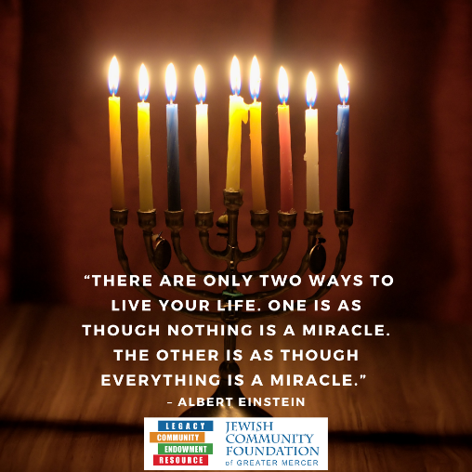
- May 18 at 5-7pm at The Jewish Center courtyard
- Next Board Meeting
In the works: Alternative ways to make a Legacy Promise – Insurance, Buy an Israel Bond, Donor Advised Funds

- JCFGM Board meeting: January 23, 2023
- JCFGM EC Meeting: February 13, 2023
- JCFGM Board meeting: March 28, 2023

Like and Share Facebook posts for Foundation!

Happy Hanukkah and New Year!

